Courses Roadmap

UI Prototype

Version 1.0

Revision History

| **Date** | **Version** | **Description** | **Author** |
| --- | --- | --- | --- |
| 11/12/2021 | 1.0 | First UI Prototype | All members |
|  |  |  |  |
|  |  |  |  |
|  |  |  |  |

Table of Contents

**Use-case Model** **4**

**UI Prototype** **5**

Register 5

Sign in 6

Sign in with Google 7

Forgot password 8

Home 9

Homepage 9

Home-Signed in 10

Catalog 11

Catalog - Web 12

Catalog - App 13

Catalog - Basic 14

Courses detail 15

Roadmap 16

User 16

User’s Profile 17

Create Information 18

Setting account - Change Information 19

Setting account - Change Password 20

Setting account - Change Social’s Information 21

Story 21

Admin 22

Admin - User 23

Admin - Course 24

Admin - Edit Course 25

Admin - Add Course 26

Admin - Add Roadmap 27

About us 27

# Use-case Model

[Link Drawio](https://app.diagrams.net/#G1lzqcdCfrSaSdY8TZXiK1Ew6EDT_YO1OF)

# 

# UI Prototype

[Link Figma](https://www.figma.com/file/c6lUcroO0aZbkJLiOTUpgJ/UI-Prototype?node-id=0%3A1)

## Register

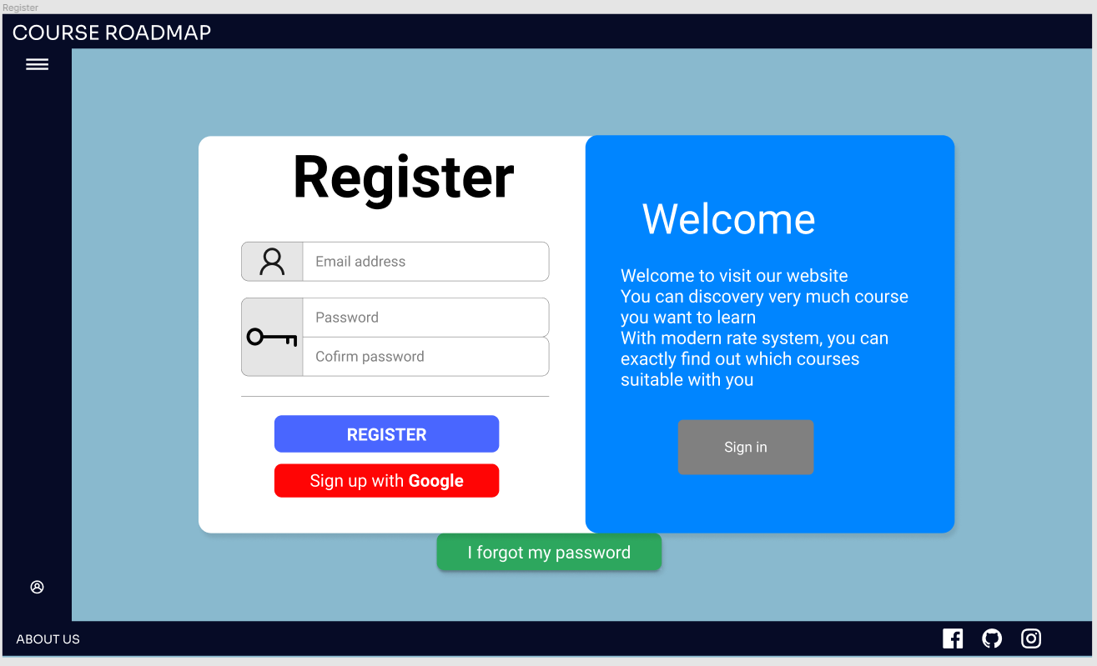

* Clicking the Sign-in button will turn to the sign-in form.

## Sign in

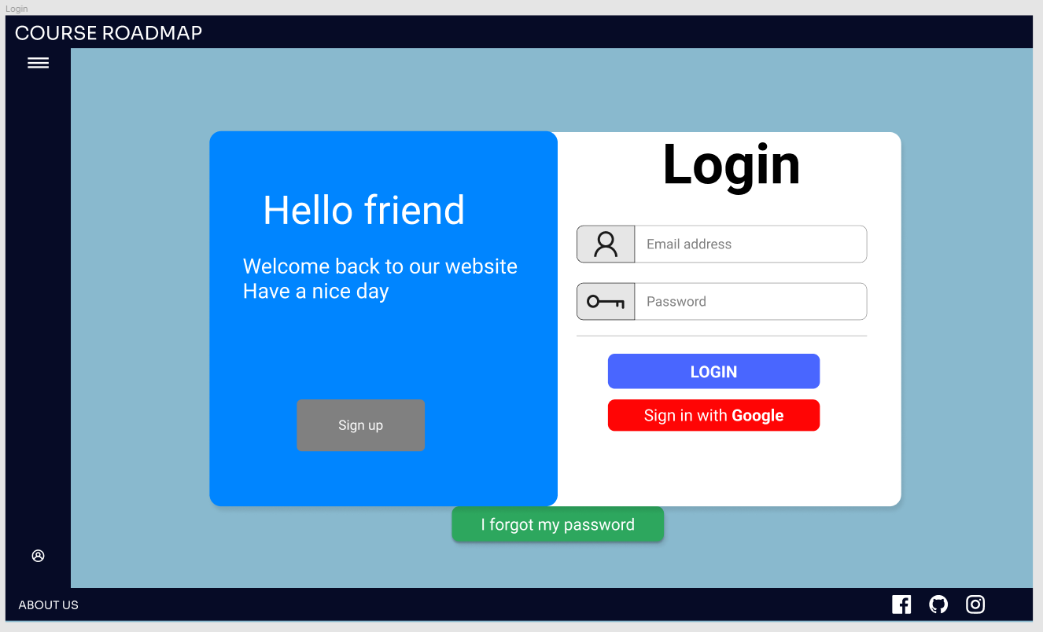

* Users who want to sign up with Google may click the Sign up with Google button.
* Users who forgot the password may click the Forgot password button.

## Sign in with Google

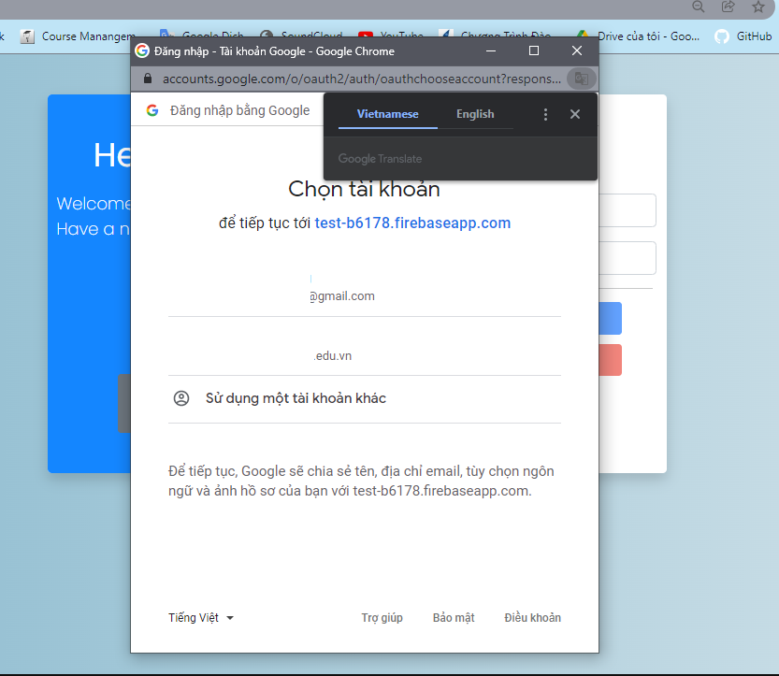

## Forgot password

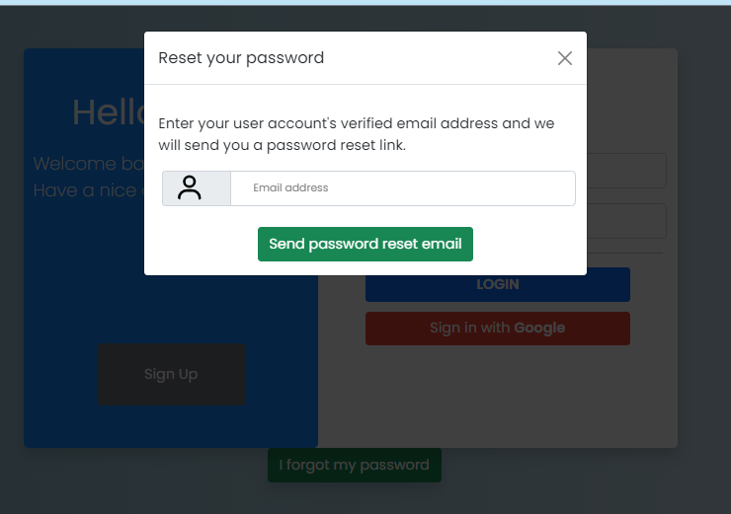

## Home

### Homepage

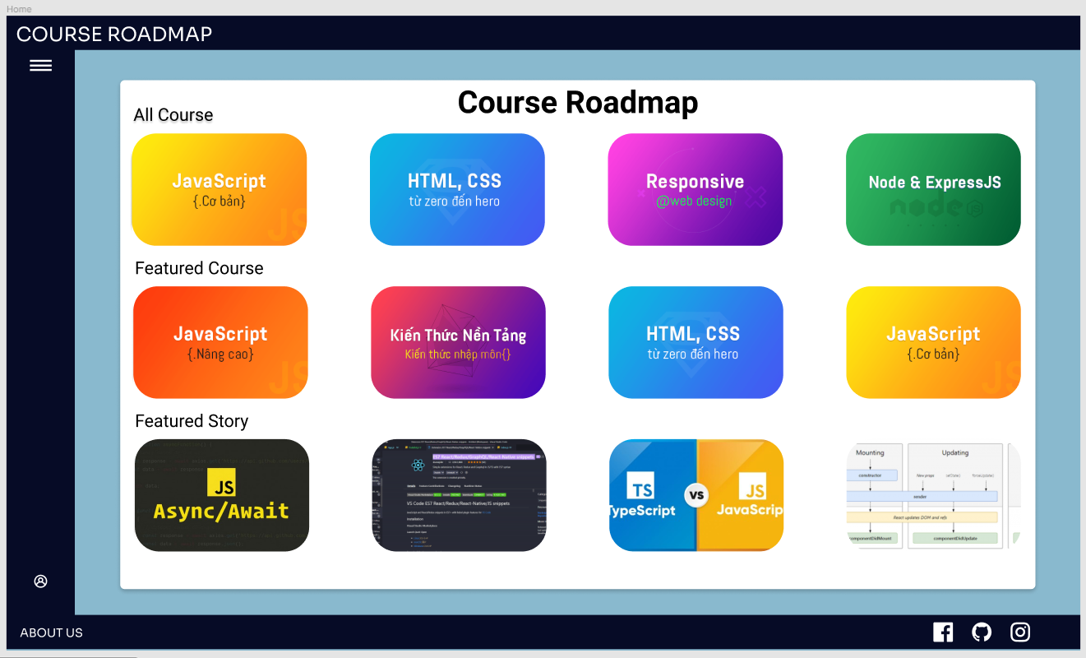

* When signed in successfully, the website will automatically navigate to the homepage.
* Clicking the Top-left navbar button will open the navbar.

### Home-Signed in



* Clicking the Catalog button will turn to the Catalog page.
* Clicking the Roadmap button will turn to the Roadmap page.
* Clicking the Story button will turn to the Story page.
* Clicking the About us button will turn to the About us page.
* Clicking the Logout button will turn to the Sign-in page.

### Catalog

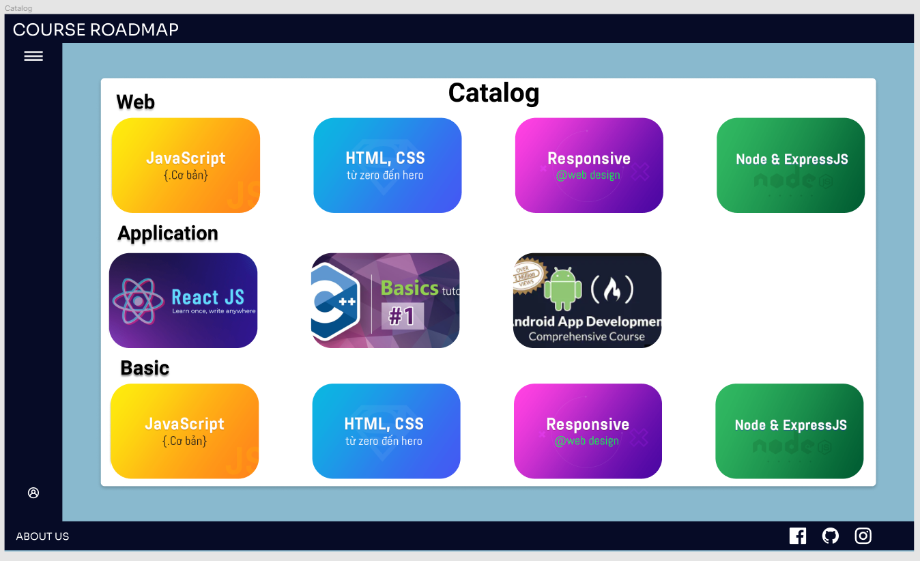

### Catalog - Web

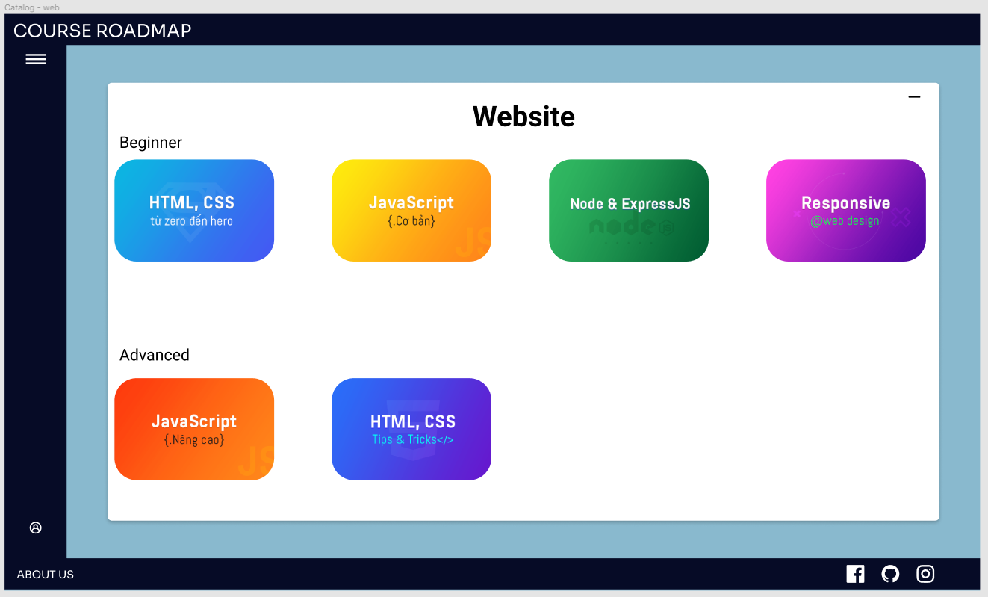

### Catalog - App

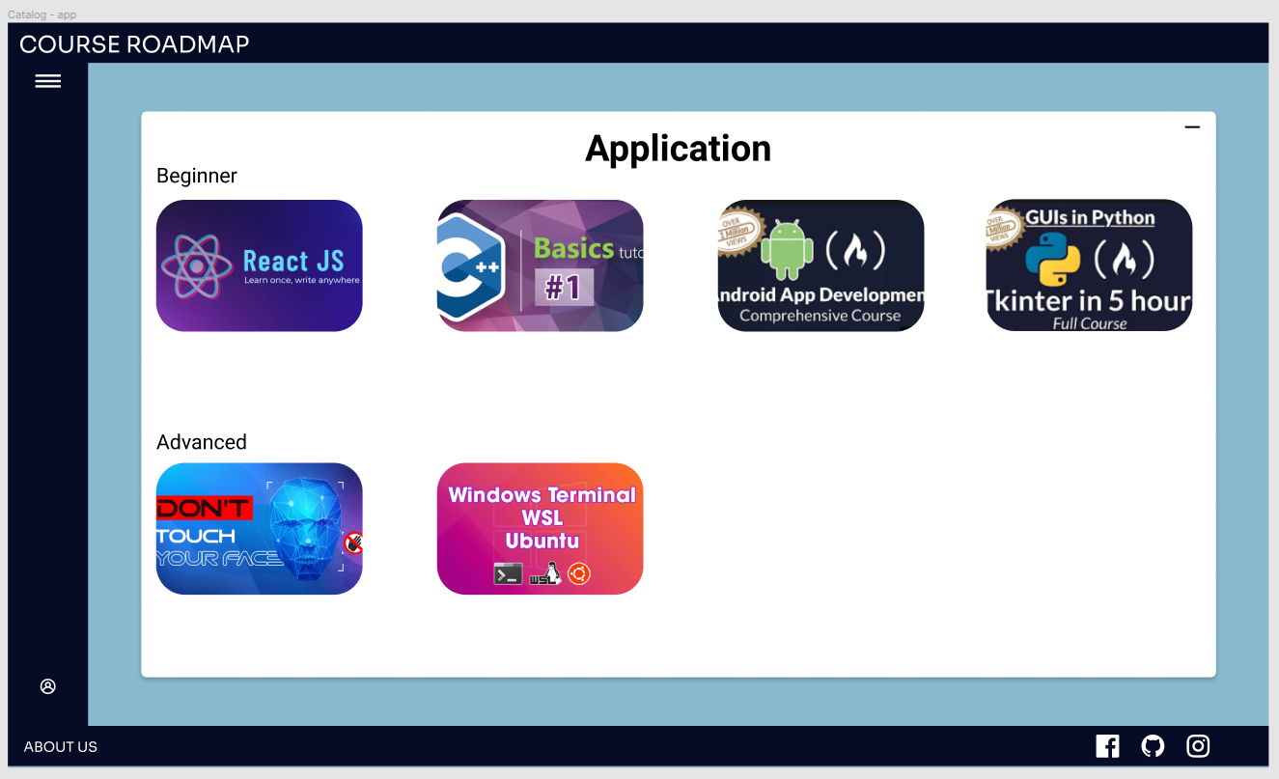

### Catalog - Basic

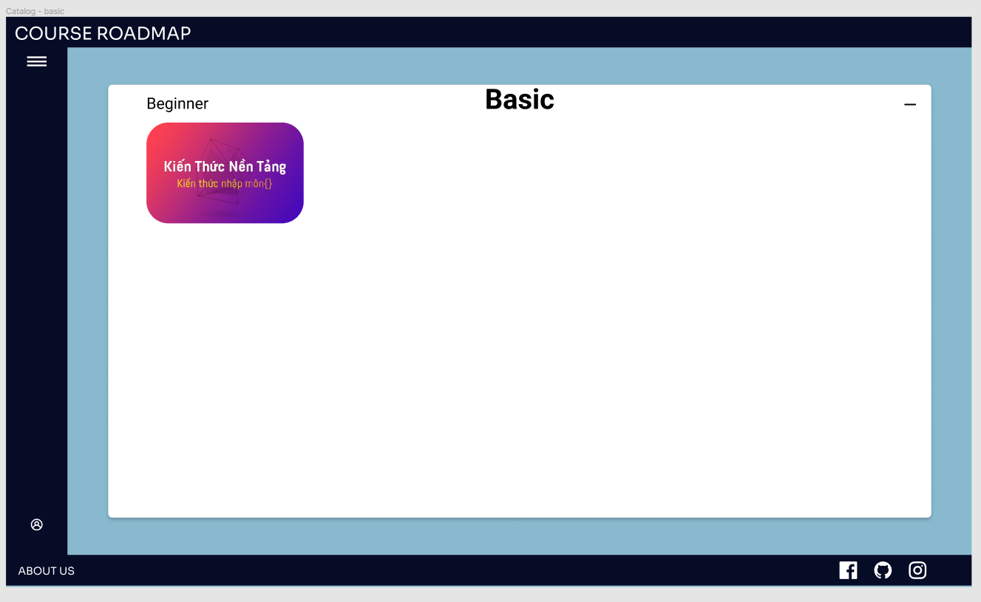

## Courses detail

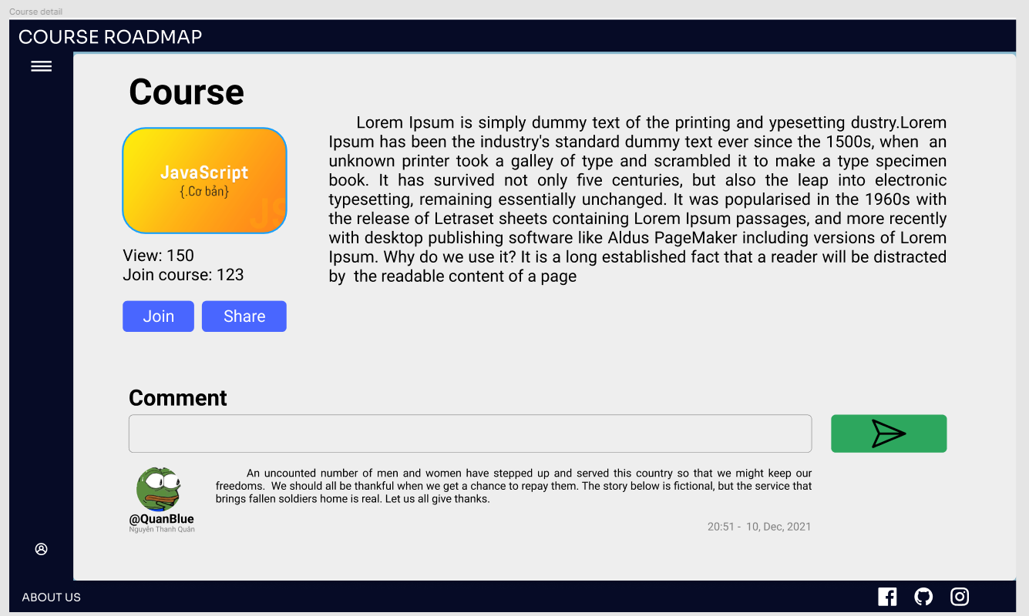

* Users who want to view the details of the course may click the Course Icon.

## Roadmap

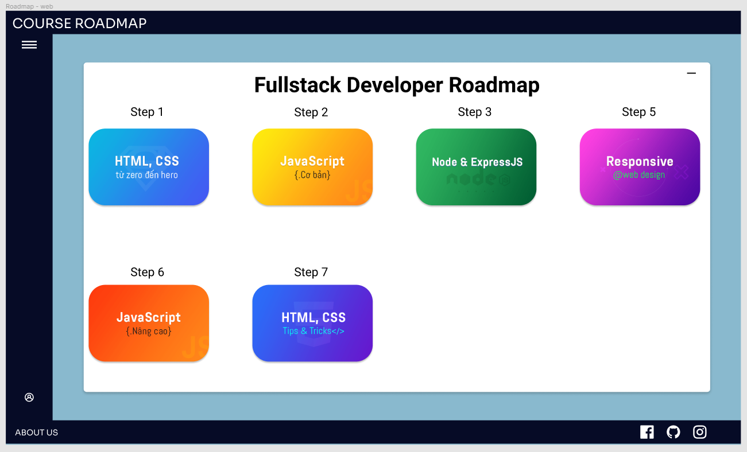

* Show courses by topic, such as web, application, programming fundamentals. When clicking the course card, it will take you to that course’s page.

## User

### User’s Profile

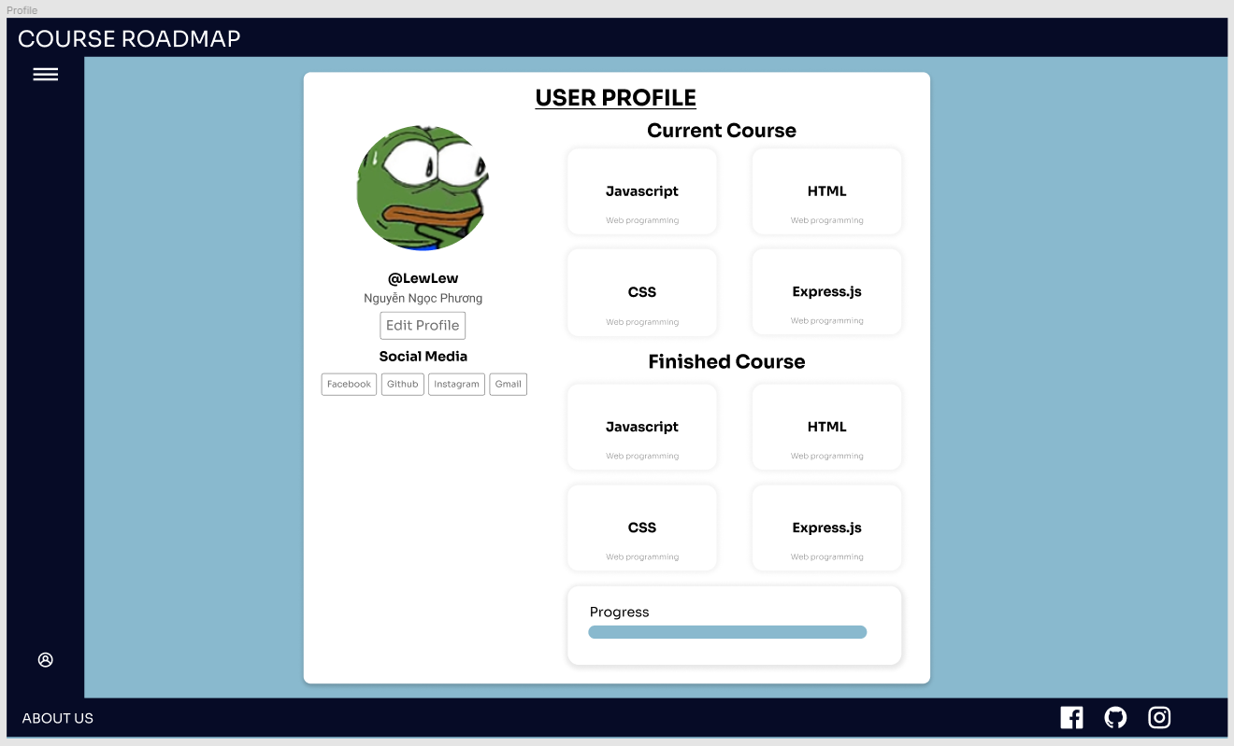

* Display user’s basic information like username, name, social media accounts. When clicking the social media buttons, it will lead the user to their facebook, github, instagram or gmail.
* Display the user's current and completed courses card. When clicking the course card, it will take them to that course.
* Display a progress bar to show how much of the course the user has enrolled in has been completed.
* The Edit Profile button will take the user to a page where they may make changes to their information.

### Create Information

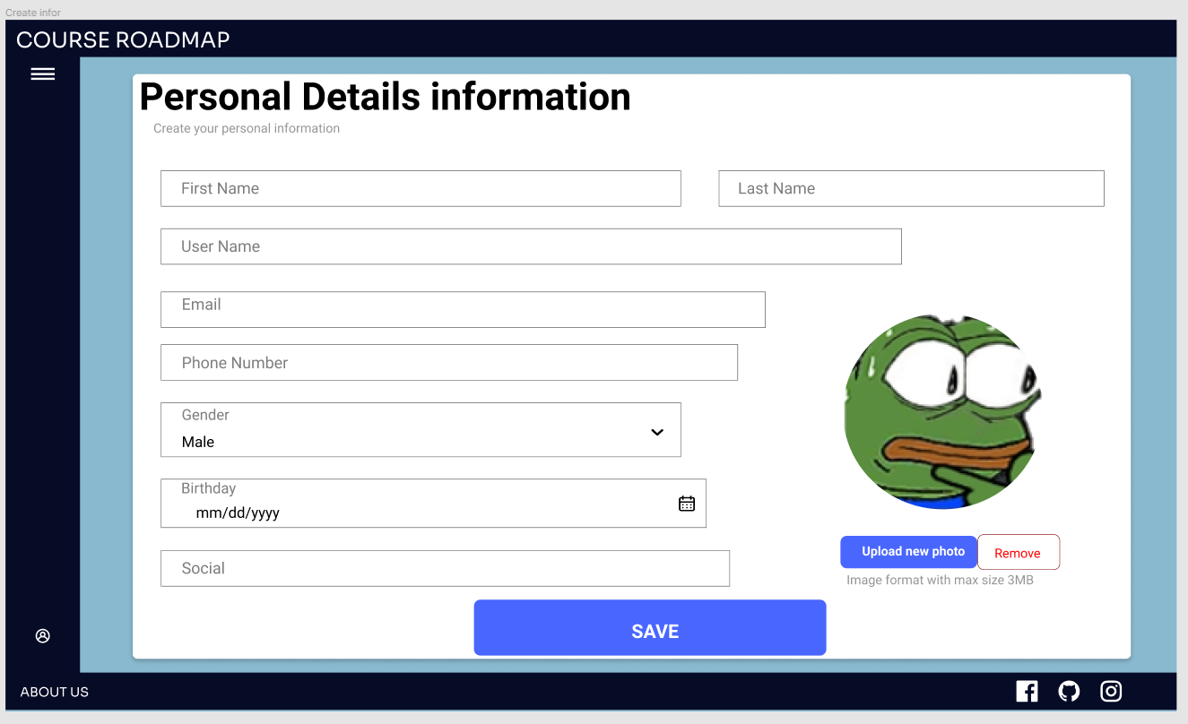

* After registration, enter personal information such as first and last name, username, email, phone number, gender, birthday, social and self photo.

### Setting account - Change Information

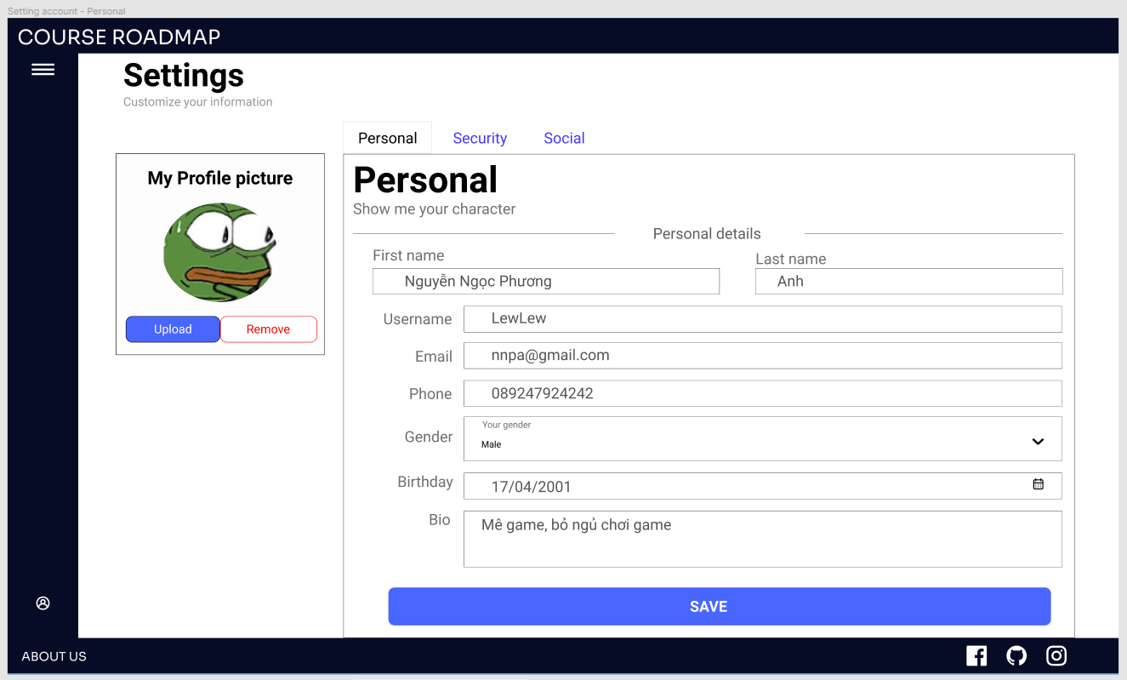

* You can change the personal information entered in Create Information as first and last name, username, email, phone number, gender, birthday, social and self photo.

### Setting account - Change Password

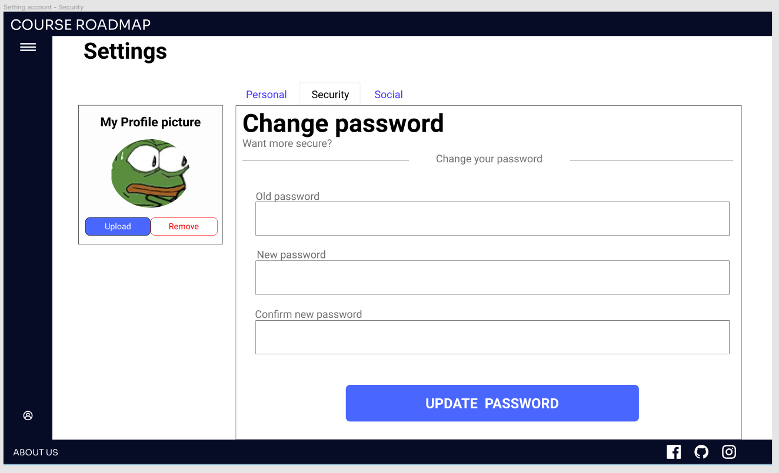

* You can change your password if you think the old password is not secure enough.
* You must enter the old password and enter the new password with the confirm new password, the new password and confirm new password must be the same.

### Setting account - Change Social’s Information

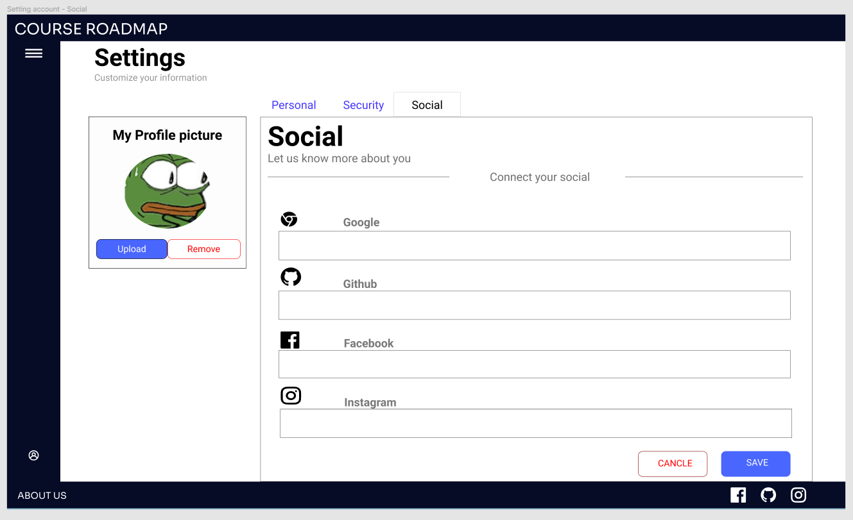

* Enter the link of your github, facebook, instagram, google accounts so people can connect to you.

## Story

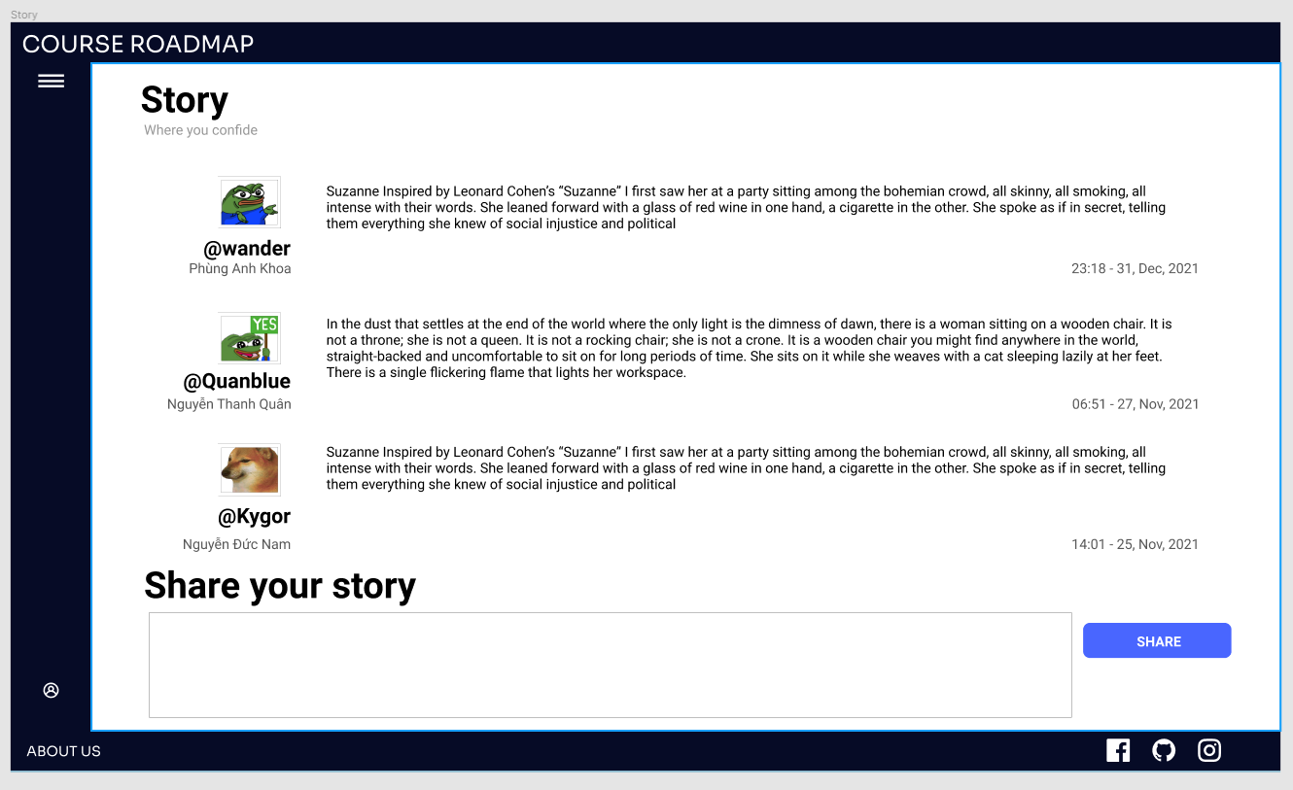

* A place for people to share their own experiences
* If someone wants to share their stories, they can fill in the box then click the share button.

## Admin

### Admin - User

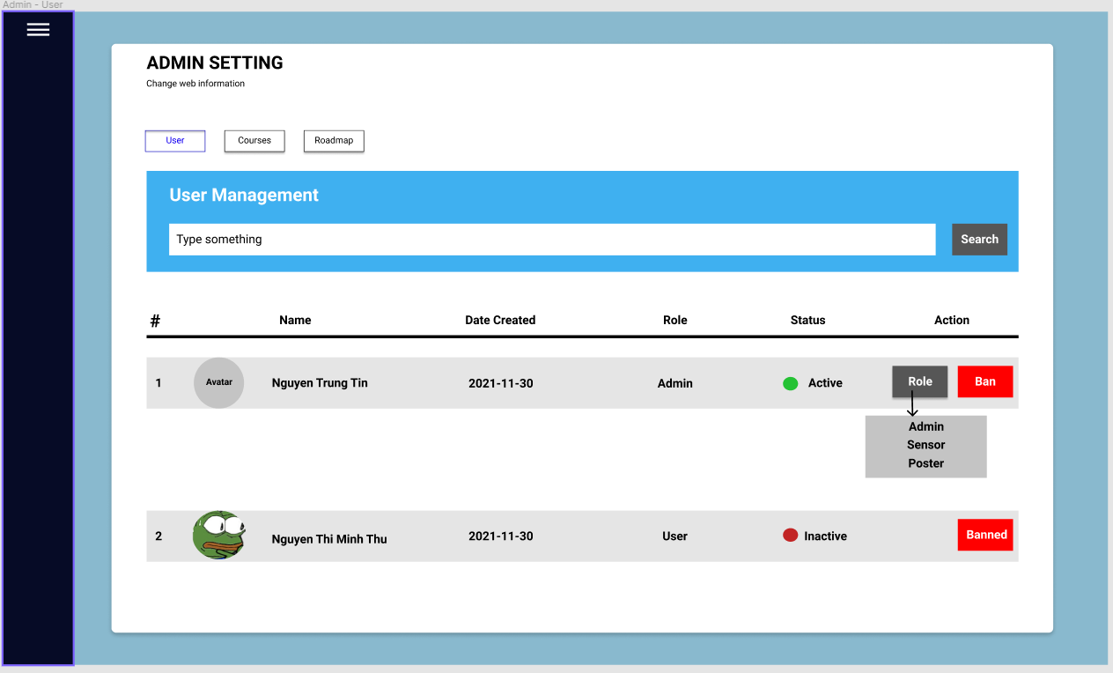

* Only the Admin can view the admin page.
* Clicking the Courses button to modify courses.
* Clicking the Roadmap button to modify roadmaps.

### Admin - Course

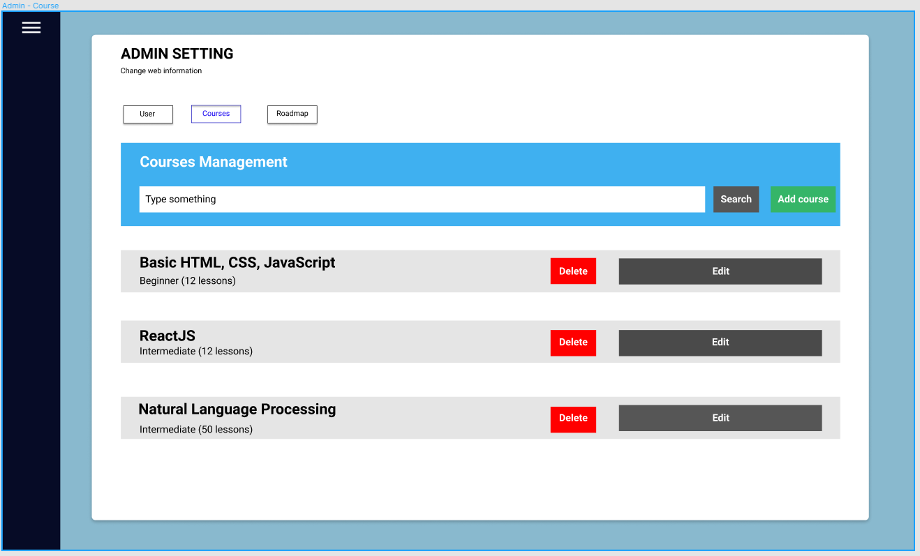

* Clicking the Delete button to delete course.
* Clicking the Edit button to edit information of course.
* Clicking the Add button to add course.

### Admin - Edit Course

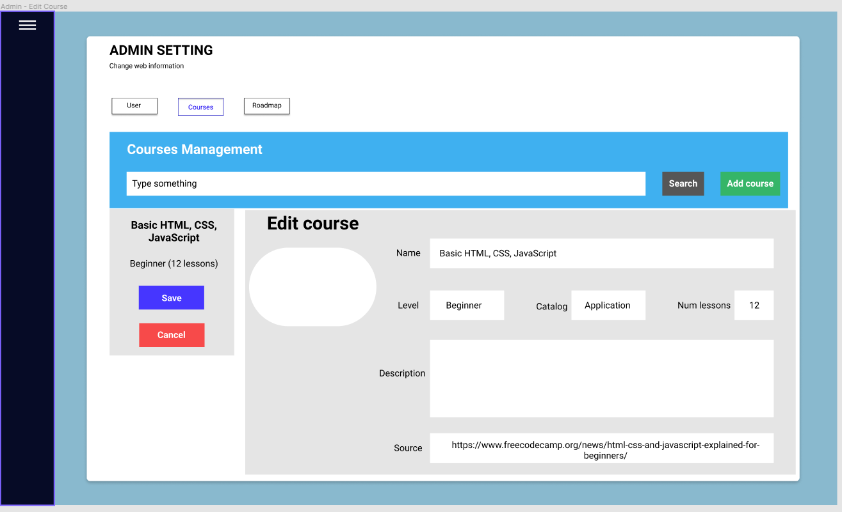

### Admin - Add Course

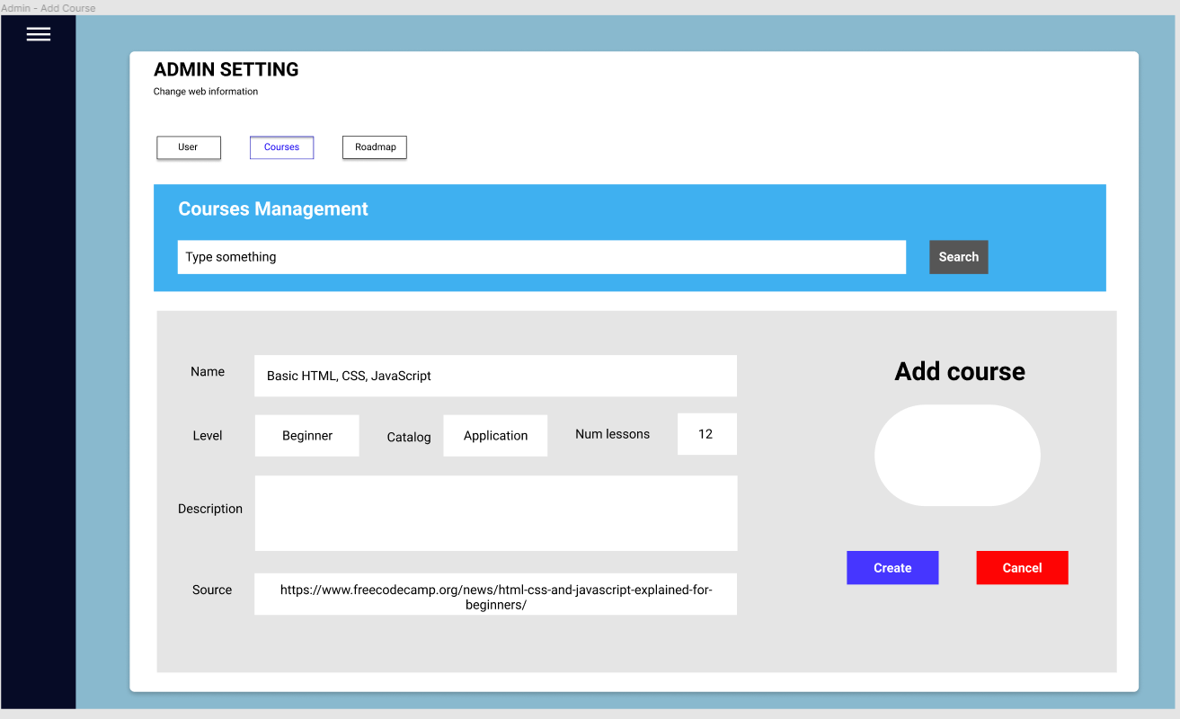

### Admin - Add Roadmap

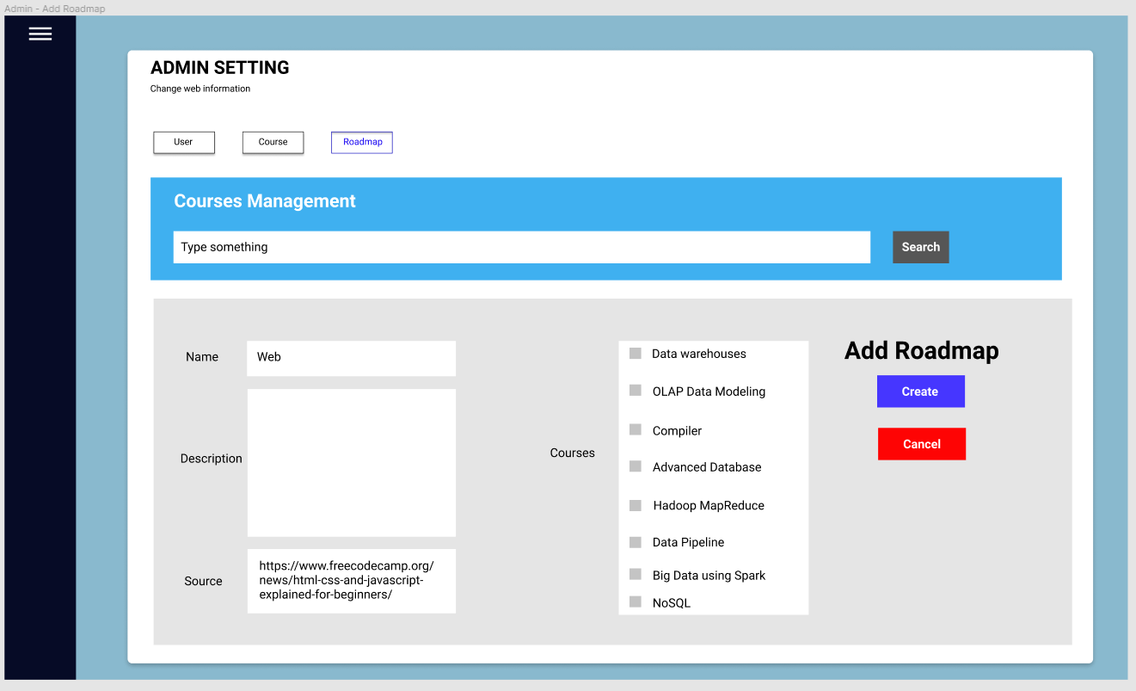

## About us

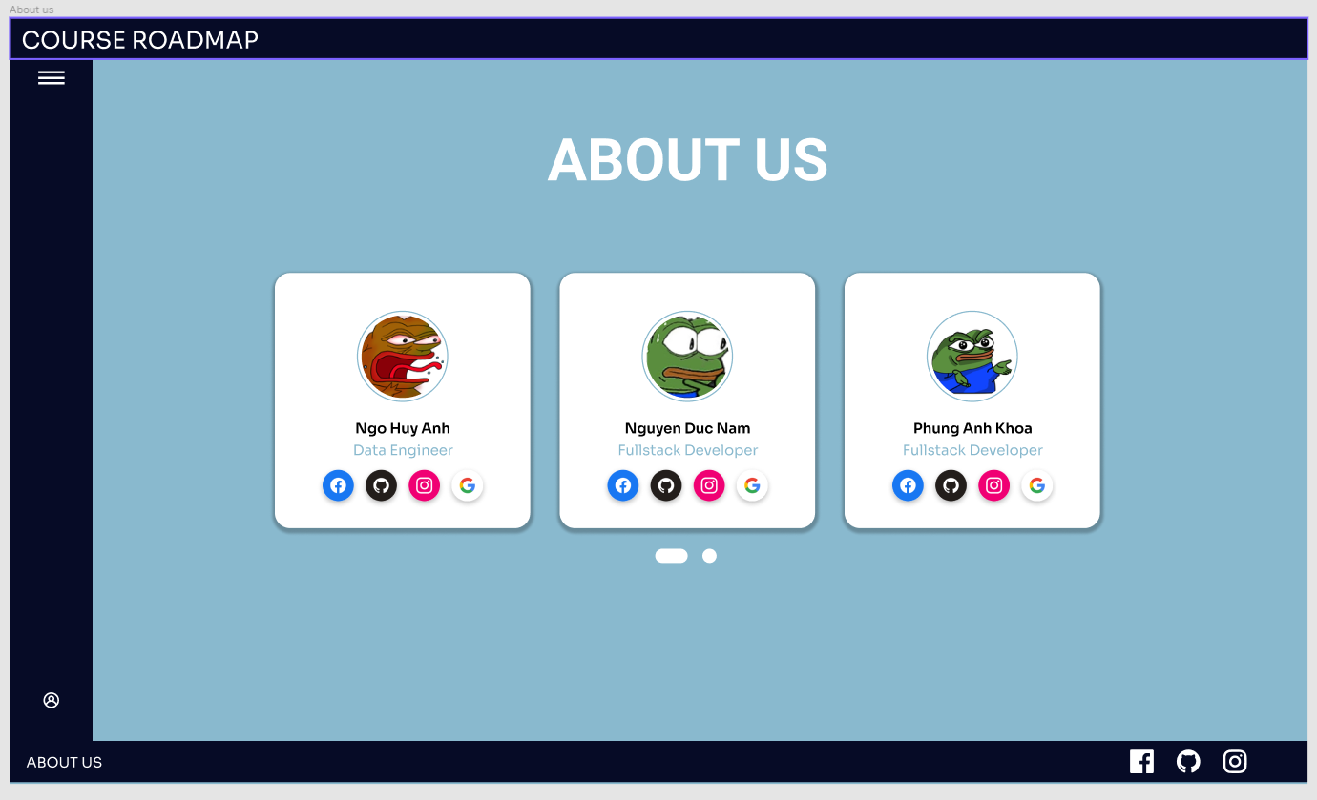

* Show the information about our group's members. Each turn contains 3 members, and there is a button below to switch between them.

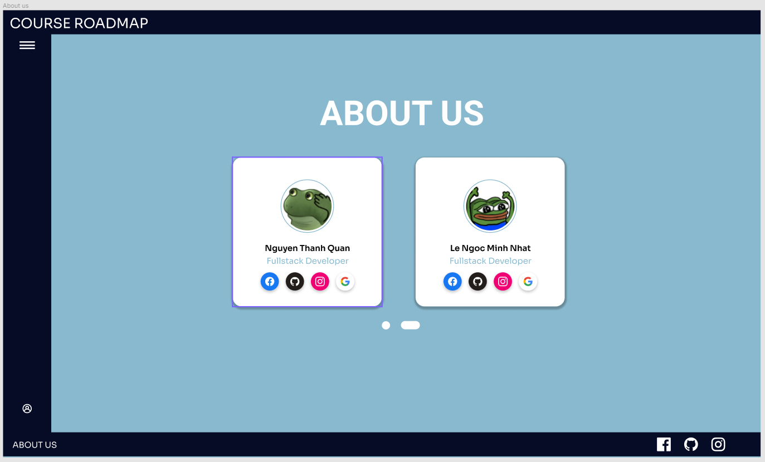

* Each information card will display each member's avatar, name, social media accounts, and role in the project.
* When clicking the social media buttons, it will lead the user to their facebook, github, instagram or gmail.